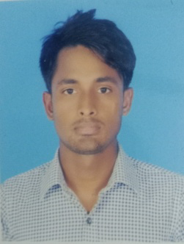
Curriculum Vitae
Name : Mostofa Bhuiyan
Father’s Name : Ohid Bhuiyan
Mother’s Name : Rabia Akter
Permanent Address : Bagjurkandi, Pardiakul, Katiadi, Kishoreganj.
Present Address : Park Mor, Cadet College, Rangpur.
Mobile No : 01627-728745
Date of Birth : 01-12-2000
Email :mcj1919022brur@gmail.com
Sex : Male
Marital Status : Unmarried
Nationality : Bangladesh Educational Qualification
Degree | Group | Board/University | Pass Year | Result(GPA)
B.S.S(Honours) | BSS (Mass Communication and Journalism) | Begum Rokeya University, Rangpur | 2023 | 3.33
H.S.C | Science | Dhaka | 2018 | 3.50
S.S.C | Science | Dhaka | 2016 | 4.44
Computer Experience : Ms Word,Ms Excel,Ms Powerpoint,Ms office Access.
I have completed Fact-checking course.
Date: 18-02-25
Signature
(Mostofa Bhuiyan)

